**Knowledge Studio:**

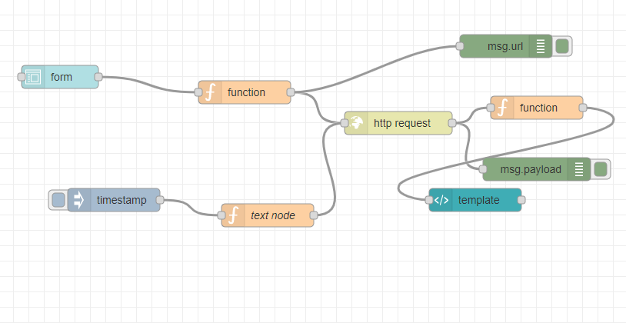

**First Function node**

URL:

msg.url = "https://gateway.watsonplatform.net/natural-language-understanding/api/v1/analyze?version=2018-03-16&text="+msg.payload.t+"&features=entities&entities.model=4dec343b-7ff3-497f-9464-b40040fc8830"

return msg;

**Second Function Node:**

**msg.payload=msg.payload.entities**

**return msg;**

**template node:**

<!DOCTYPE html>

<html lang="en">

<head>

<title>SMS analysis</title>

<meta charset="utf-8">

<meta name="viewport" content="width=device-width, initial-scale=1">

<link rel="stylesheet" href="https://maxcdn.bootstrapcdn.com/bootstrap/4.3.1/css/bootstrap.min.css">

<script src="https://ajax.googleapis.com/ajax/libs/jquery/3.4.1/jquery.min.js"></script>

<script src="https://cdnjs.cloudflare.com/ajax/libs/popper.js/1.14.7/umd/popper.min.js"></script>

<script src="https://maxcdn.bootstrapcdn.com/bootstrap/4.3.1/js/bootstrap.min.js"></script>

<style>

.bg-light {

background-color: #00838F!important;

}

h4 {

color: #fff;

}

.custom-file {

margin-bottom: 14px;

}

.table .thead-dark th {

color: #fff;

background-color: #307d76;

border-color: #307d76;

}

h5{

text-align: center;

color: #bd6666;

}

.text-center {

text-align: center;

}

.imgdiv

{

align:center;

}

</style>

</head>

<body>

<nav class="navbar navbar-expand-sm bg-light">

<div class="justify-content-center">

</div>

</nav>

<br><br>

<div class="container">

<div class="row">

<div class="col-sm-2">

</div>

<div class="col-sm-8">

<br>

<!--<md-button ng-click="send({payload:action()})">

Predict

</md-button>-->

</div>

<div class="col-sm-2">

</div>

</div>

<div class="row">

<div class="col-sm-2">

</div>

<div class="col-sm-8">

<h5> Analysed SMS </h5>

<table class="table">

<thead class="thead-dark">

<tr>

<th>Type</th>

<th>Text</th>

<th>Confidence</th>

</tr>

</thead>

<tbody id="scoretable">

</tbody>

</table>

</div>

<div class="col-sm-2">

</div>

</div>

</body>

</html>

<script>

var x="";

function readURL(input) {

if (input.files && input.files[0]) {

var reader = new FileReader();

reader.onload = function (e) {

$('#blah')

.attr('src', e.target.result)

.width(150)

.height(200);

};

reader.readAsDataURL(input.files[0]);

x= input.files[0]

}

}

function getdata(data)

{

var html = '';

if(data != 0)

{

$.each(data, function(i){

var row = data[i];

console.log(row);

html += '<tr>';

html += '<td>';

html += row.type;

html += '<td>';

html += row.text;

html += '</td>';

html += '<td>';

html += row.confidence;

html += '</td>';

html += '</tr>';

});

}

else

html+="<div>No Data</div>";

$('#scoretable').html(html);

}

(function(scope) {

scope.$watch('msg.payload', function(data) {

console.log('Position 2');

console.dir(data);

getdata(data);

});

})(scope);

// or overwrite value in your callback function ...

this.scope.action = function() { return x; }

</script>